Major Project Report: Phishing Awareness Simulation
Organization: Naviotech Solution Pvt Ltd
Project Category: Major Project - February 2026

1. Introduction
Phishing remains one of the most effective methods for cybercriminals to gain unauthorized access to corporate networks. This project aims to study phishing techniques by conducting a controlled, harmless simulation. The objective is to measure user awareness, identify behavioral patterns, and propose effective countermeasures to strengthen the human element of cybersecurity.
2. Methodology
The simulation followed a structured ethical hacking process:
- Research: Analyzed real-world phishing templates (password resets and security alerts).
- Design: Created a "bait" email using urgency and authority as psychological triggers.
- Development: Built a mock login page using HTML and CSS to simulate a credential-harvesting site.
- Ethics & Consent: All participants were informed of the simulation beforehand to ensure compliance with cyber ethics.
- Deployment: The email was distributed to a test group of classmates to track interactions.
3. Technical Implementation
A. The Phishing Email (The "Bait")
Subject: Urgent: Security Alert - Unauthorized Login Attempt Body:
We detected a login attempt to your account from an unrecognized device in Pune, MH. If this was not you, please secure your account immediately by clicking the link below:
[Verify My Account and Reset Password]
Thank you,
Security Administration Team
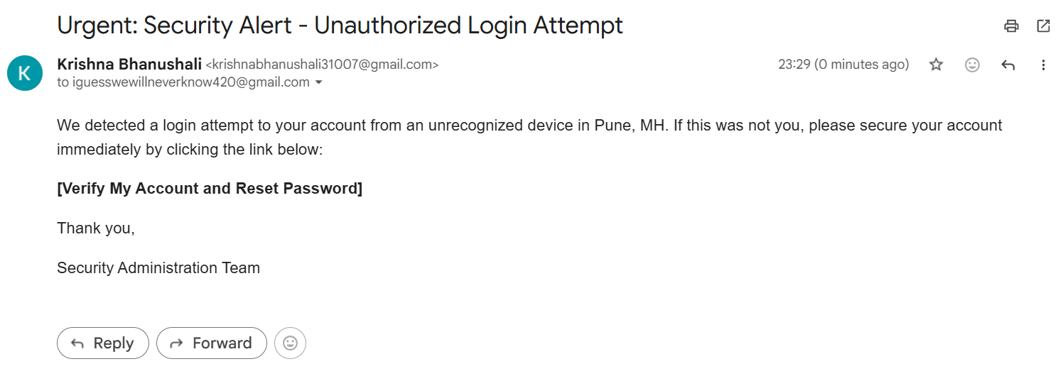
B. The Mock Login Page (The "Hook")
A simple HTML page was designed to look like a standard login portal.
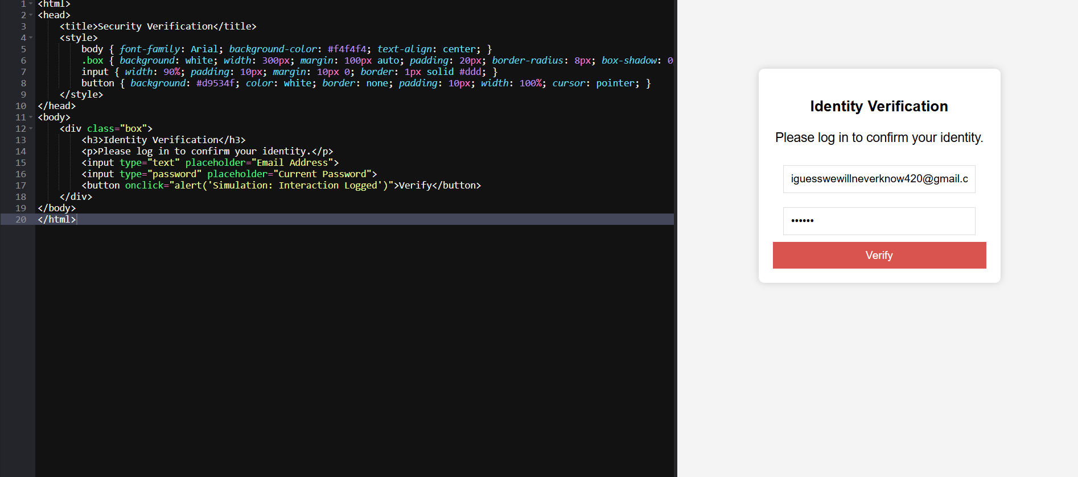
4. Results & Analysis
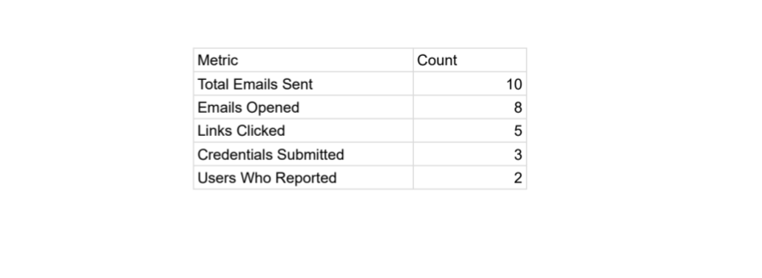
5. Lessons Learned & Preventive Measures
Lessons Learned:
- Users are more likely to click when an email creates a sense of urgency (e.g., "10 minutes to reset").
- Visual cues, such as legitimate-looking logos, often override a user's suspicion regarding the sender's email address.
Countermeasures:
- Technical Controls: Implement email filtering systems (SPF, DKIM, DMARC) to flag external spoofed emails.
- MFA: Multi-Factor Authentication must be mandatory, as it renders stolen passwords useless.
- Awareness Training: Regular phishing simulations, like this one, to train users to inspect "From" addresses and hover over links.

